BACHU TEJASWINI
2303A54057[B-48]
AI Assisted Coding
ASS NO – 6.3
Task Description #1: Classes (Student Class)
Task : Use an AI tool (GitHub Copilot / Cursor AI / Gemini) to complete a Student class.
Expected Output #1
• A Python class with a constructor (__init__) and a display_details() method.
• Sample object creation and output displayed on the console.
• Brief analysis of AI-generated code
Prompt: generate a python code to print the student details it should contain:
-a student class that contains attributes such as name,roll number and branch
-method display_details() to display the student details
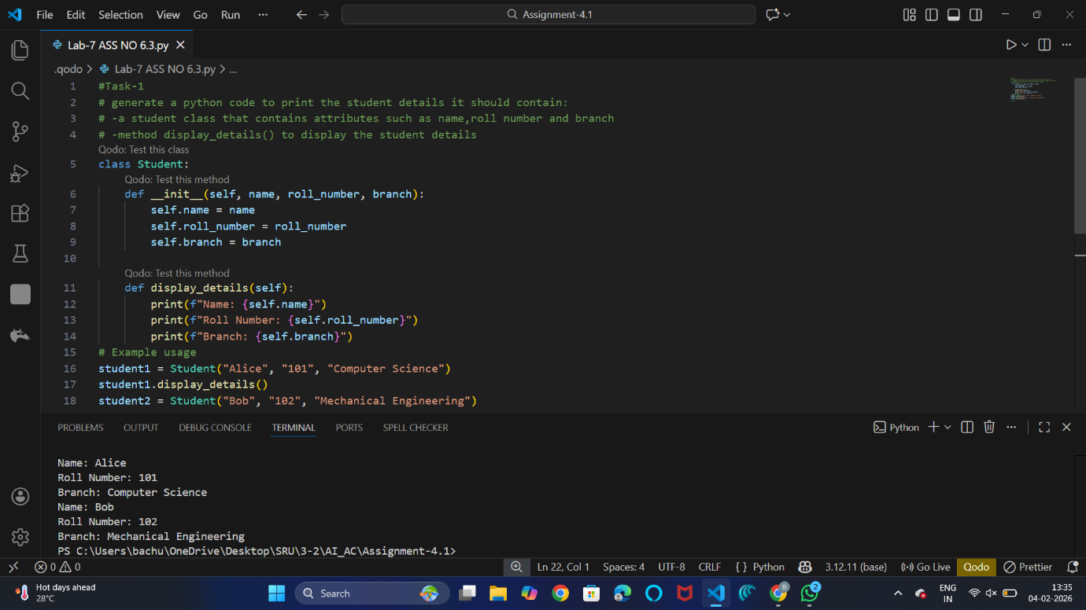
EXPLANATION: # The code defines a Student class with attributes for name, roll number, and branch. It includes a method display_details() that prints the student's details. Two instances of the Student class are created to demonstrate its functionality.
Task Description #2: Loops (Multiples of a Number)
Task:•Prompt the AI tool to generate a function that prints the first 10 multiples of a given number using a loop.• Analyze the generated loop logic.• Ask the AI to generate the same functionality using another controlled looping structure (e.g.,while instead of for).Expected Output: • Identified privacy risks.• Revised version with encrypted password storage (e.g., hashing).
Prompt : generate a function that prints the first 10 multiples of a given number using a both loops and compare and analyze of different looping approaches.
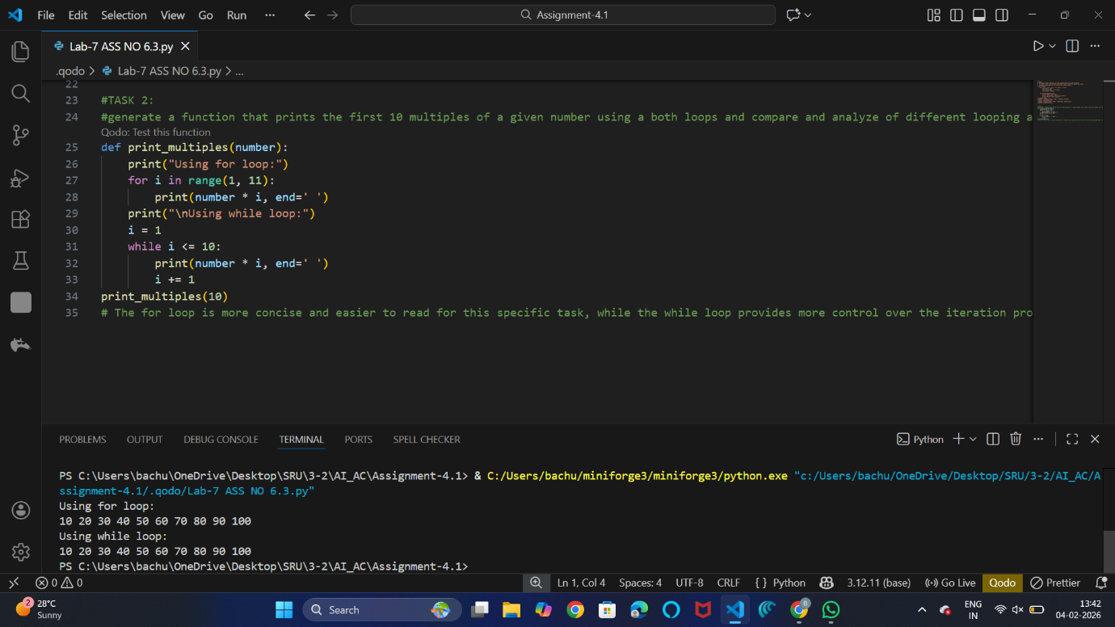
Explanation : In the for loop, we directly iterate over a range of numbers from 1 to 10, which makes it straightforward to generate the multiples.In the while loop, we manually control the loop variable 'i', which requires initialization and incrementing, making it slightly more verbose.
Task Description #3: Conditional Statements (Age Classification)
Task:• Ask the AI tool to generate nested if-elif-else conditional statements to classify age groups(e.g., child, teenager, adult, senior).• Analyze the generated conditions and logic.• Ask the AI to generate the same classification using alternative conditional structures (e.g.,simplified conditions or dictionary-based logic).
Expected Output #3• A Python function that classifies age into appropriate groups.• Clear and correct conditional logic.• Explanation of how the conditions work.
Prompt : generate a asic classification system based on age using nested if elif else conditional statements to classify age groups.
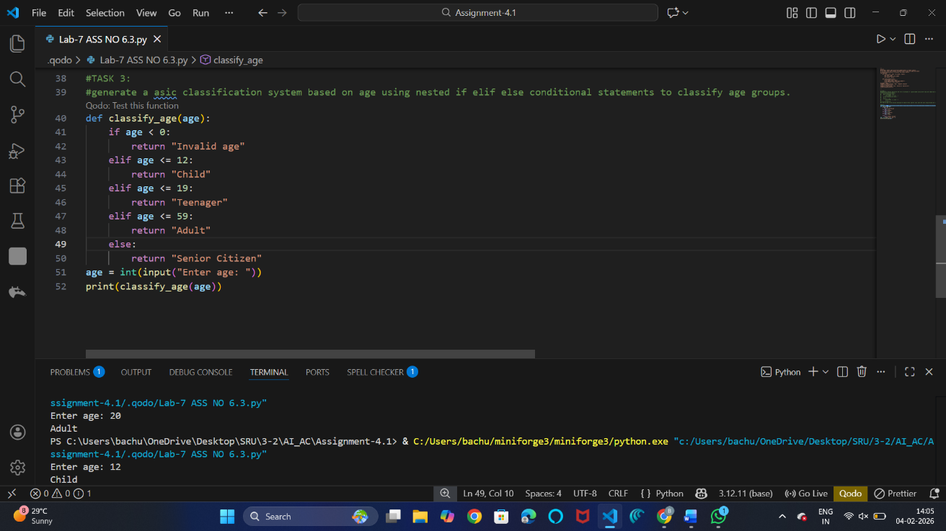
Explanation:
The function classify_age uses nested if-elif-else statements to classify the age into different groups: Child, Teenager, Adult, and Senior Citizen. It also checks for invalid age input.
Task Description #4: For and While Loops (Sum of First n Numbers)
Task:• Use AI assistance to generate a sum_to_n() function using a for loop.• Analyze the generated code.• Ask the AI to suggest an alternative implementation using a while loop or a mathematical formula.
Expected Output #4• Python function to compute the sum of first n numbers.• Correct output for sample inputs.• Explanation and comparison of different approaches
Prompt: generate a function to calculate the sum of the first n natural numbers and to generate a sum_to_n() function using a while or math formula.
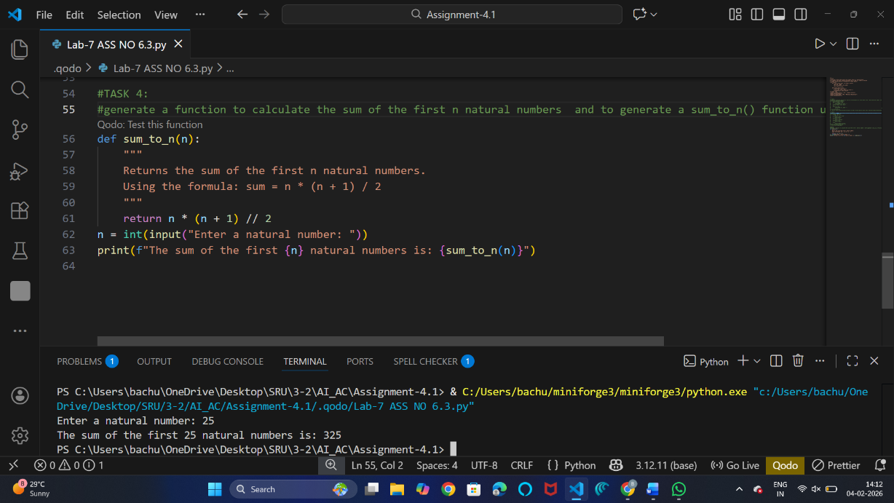
Explanation: The formula n * (n + 1) / 2 provides a direct way to calculate the sum of the first n natural numbers without needing to iterate through each number, making it more efficient.
Task Description #5: Classes (Bank Account Class)
Task:•Use AI tools to generate a Bank Account class with methods such as deposit(), withdraw(),and check_balance().• Analyze the AI-generated class structure and logic.• Add meaningful comments and explain the working of the code.
Expected Output #5• Complete Python Bank Account class.• Demonstration of deposit and withdrawal operations with updated balance.• Well-commented code with a clear explanation.
Prompt : generate a function Bank Account class with methods such as deposit(), withdraw(),and check_balance() with comments explaining each method.
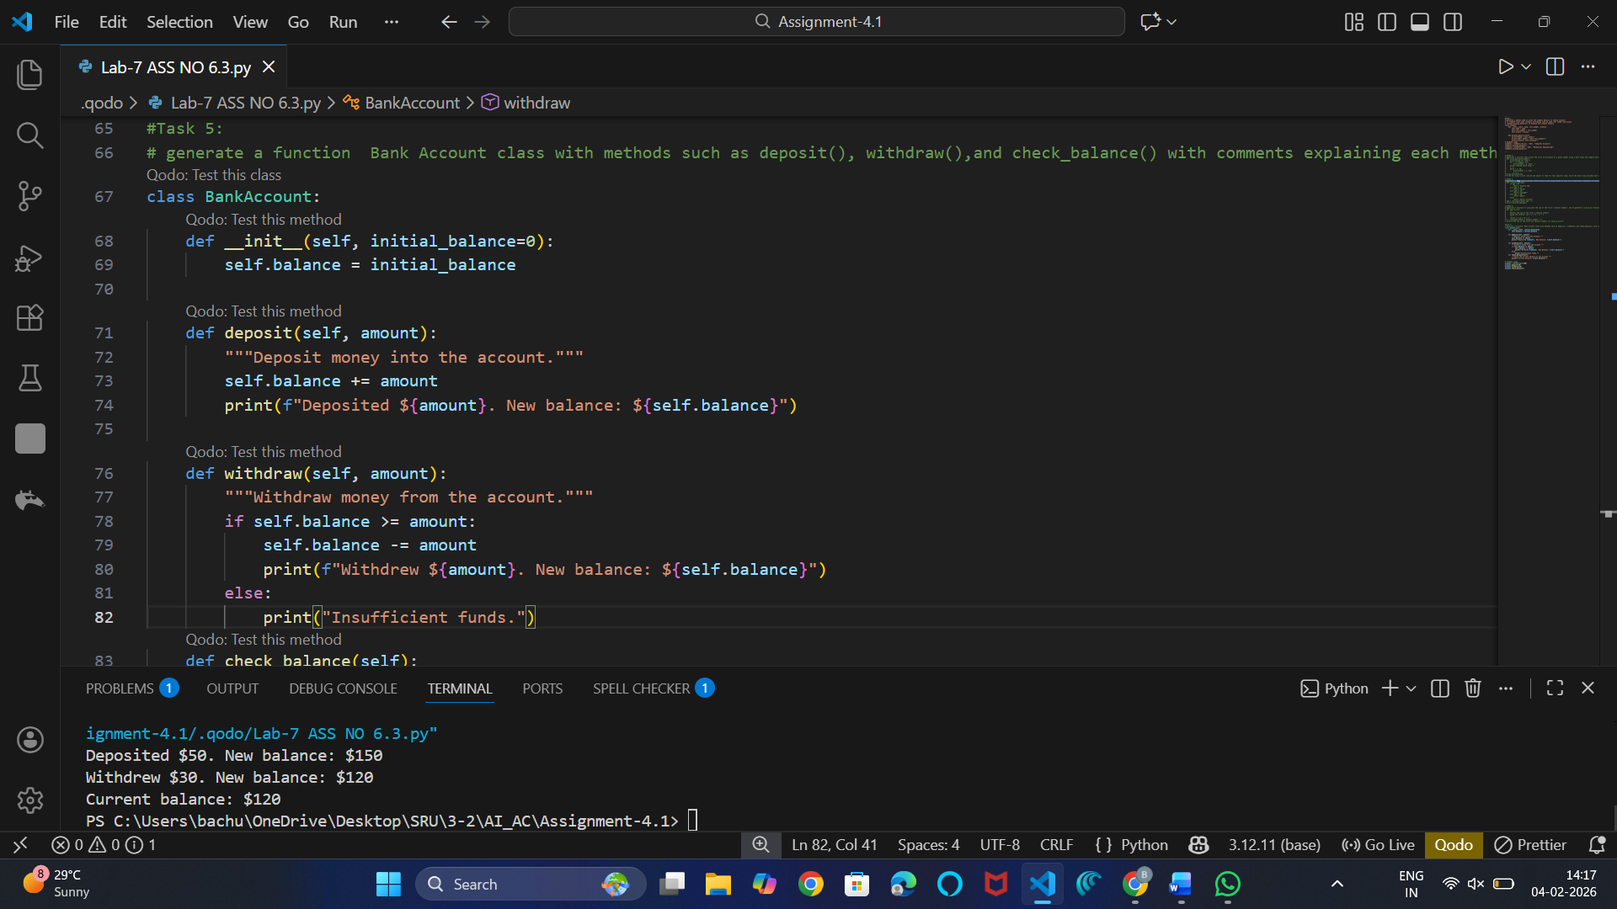
Explanation:
-The BankAccount class simulates a simple bank account with an initial balance.
-The deposit() method allows adding money to the account.
-The withdraw() method allows taking money out of the account, checking for sufficient funds.
-The check_balance() method displays the current balance of the account.

